**Name: Rohit Vilas Patil**

**Roll No.: 31353**

**Assignment : Virtualization using KVM (install and configure KVM)**

**Step 1: Check if system is compatible or not for virtualization**

**pict@pict-OptiPlex-9020:~$ egrep -c '(vmx|svm)' /proc/cpuinfo**

**16**

**pict@pict-OptiPlex-9020:~$ sudo kvm-ok**

**[sudo] password for pict:**

**INFO: /dev/kvm exists**

**KVM acceleration can be used**

**Step 2: Update Packages**

**pict@pict-OptiPlex-9020:~$ sudo apt update**

**Get:1 http://packages.microsoft.com/repos/code stable InRelease [3,569 B] Get:2 http://security.ubuntu.com/ubuntu focal-security InRelease [114 kB] Hit:3 https://dl.google.com/linux/chrome/deb stable InRelease**

**Hit:4 http://in.archive.ubuntu.com/ubuntu focal InRelease**

**Hit:5 http://in.archive.ubuntu.com/ubuntu focal-updates InRelease Fetched 117 kB in 1s (139 kB/s)**

**Reading package lists... Done**

**Building dependency tree**

**Reading state information... Done**

**110 packages can be upgraded. Run 'apt list --upgradable' to see them. Step 3: Install required packages**

**pict@pict-OptiPlex-9020:~$ sudo apt install qemu-kvm libvirt-daemon-system libvirt clients bridge-utils**

**Reading package lists... Done**

**Building dependency tree**

**Reading state information... Done**

**bridge-utils is already the newest version (1.6-2ubuntu1).**

**libvirt-clients is already the newest version (6.0.0-0ubuntu8.16).**

**libvirt-daemon-system is already the newest version (6.0.0-0ubuntu8.16). The following packages were automatically installed and are no longer required: libfprint-2-tod1 libfwupdplugin1**

**Use 'sudo apt autoremove' to remove them.**

**Suggested packages:**

**samba vde2 qemu-block-extra**

**The following packages will be upgraded:**

**qemu-kvm qemu-system-data qemu-system-gui qemu-system-x86 4 upgraded, 0 newly installed, 0 to remove and 106 not upgraded.**

**Need to get 7,337 kB of archives.**

**After this operation, 0 B of additional disk space will be used.**

**Get:1 http://in.archive.ubuntu.com/ubuntu focal-updates/main amd64 qemu-system-data all 1:4.2-3ubuntu6.25 [563 kB]**

**Get:2 http://in.archive.ubuntu.com/ubuntu focal-updates/main amd64 qemu-kvm amd64 1:4.2-3ubuntu6.25 [13.1 kB]**

**Get:3 http://in.archive.ubuntu.com/ubuntu focal-updates/main amd64 qemu-system-x86 amd64 1:4.2-3ubuntu6.25 [6,721 kB]**

**Get:4 http://in.archive.ubuntu.com/ubuntu focal-updates/main amd64 qemu-system-gui amd64 1:4.2-3ubuntu6.25 [40.7 kB]**

**Fetched 7,337 kB in 6s (1,236 kB/s)**

**(Reading database ... 254793 files and directories currently installed.) Preparing to unpack .../qemu-system-data_1%3a4.2-3ubuntu6.25_all.deb ... Unpacking qemu-system-data (1:4.2-3ubuntu6.25) over (1:4.2-3ubuntu6.24) ... Preparing to unpack .../qemu-kvm_1%3a4.2-3ubuntu6.25_amd64.deb ... Unpacking qemu-kvm (1:4.2-3ubuntu6.25) over (1:4.2-3ubuntu6.24) ...**

**Preparing to unpack .../qemu-system-x86_1%3a4.2-3ubuntu6.25_amd64.deb ... Unpacking qemu-system-x86 (1:4.2-3ubuntu6.25) over (1:4.2-3ubuntu6.24) ... Preparing to unpack .../qemu-system-gui_1%3a4.2-3ubuntu6.25_amd64.deb ... Unpacking qemu-system-gui:amd64 (1:4.2-3ubuntu6.25) over (1:4.2-3ubuntu6.24) ... Setting up qemu-system-gui:amd64 (1:4.2-3ubuntu6.25) ...**

**Setting up qemu-system-data (1:4.2-3ubuntu6.25) ...**

**Setting up qemu-system-x86 (1:4.2-3ubuntu6.25) ...**

**Setting up qemu-kvm (1:4.2-3ubuntu6.25) ...**

**Processing triggers for desktop-file-utils (0.24-1ubuntu3) ...**

**Processing triggers for mime-support (3.64ubuntu1) ...**

**Processing triggers for hicolor-icon-theme (0.17-2) ...**

**Processing triggers for gnome-menus (3.36.0-1ubuntu1) ...**

**Processing triggers for man-db (2.9.1-1) ...**

**Step 4: Add currentuser in libvirt and kvm group**

**pict@pict-OptiPlex-9020:~$ sudo adduser 'pict' libvirt**

**The user `pict' is already a member of `libvirt'.**

**pict@pict-OptiPlex-9020:~$ sudo adduser 'pict' kvm**

**Adding user `pict' to group `kvm' ...**

**Adding user pict to group kvm**

**Done.**

**Step 5: check service status of Virtualization Daemon Service**

**pict@pict-OptiPlex-9020:~$ sudo systemctl status libvirtd**

**● libvirtd.service - Virtualization daemon**

**Loaded: loaded (/lib/systemd/system/libvirtd.service; enabled; vendor pres> Active: active (running) since Thu 2023-04-20 11:05:39 IST; 36min ago TriggeredBy: ● libvirtd.socket**

**● libvirtd-ro.socket**

**● libvirtd-admin.socket**

**Docs: man:libvirtd(8)**

**https://libvirt.org**

**Main PID: 876 (libvirtd)**

**Tasks: 19 (limit: 32768)**

**Memory: 39.7M**

**CGroup: /system.slice/libvirtd.service**

**├─ 876 /usr/sbin/libvirtd**

**├─1258 /usr/sbin/dnsmasq --conf-file=/var/lib/libvirt/dnsmasq/defa> └─1259 /usr/sbin/dnsmasq --conf-file=/var/lib/libvirt/dnsmasq/defa>**

**Apr 20 11:05:42 pict-OptiPlex-9020 dnsmasq-dhcp[1258]: DHCP, sockets bound excl> Apr 20 11:05:42 pict-OptiPlex-9020 dnsmasq[1258]: reading /etc/resolv.conf Apr 20 11:05:42 pict-OptiPlex-9020 dnsmasq[1258]: using nameserver 127.0.0.53#53 Apr 20 11:05:42 pict-OptiPlex-9020 dnsmasq[1258]: read /etc/hosts - 7 addresses Apr 20 11:05:42 pict-OptiPlex-9020 dnsmasq[1258]: read /var/lib/libvirt/dnsmasq> Apr 20 11:05:42 pict-OptiPlex-9020 dnsmasq-dhcp[1258]: read /var/lib/libvirt/dn> Apr 20 11:06:18 pict-OptiPlex-9020 dnsmasq[1258]: reading /etc/resolv.conf Step 6: Install Virtual Manager**

**pict@pict-OptiPlex-9020:~$ sudo apt install virt-manager**

**Reading package lists... Done**

**Building dependency tree**

**Reading state information... Done**

**virt-manager is already the newest version (1:2.2.1-3ubuntu2.1).**

**The following packages were automatically installed and are no longer required:**

**libfprint-2-tod1 libfwupdplugin1**

**Use 'sudo apt autoremove' to remove them.**

**0 upgraded, 0 newly installed, 0 to remove and 106 not upgraded.**

**Step 7: Launch Virtual manager and import ISO file to install Guest OS pict@pict-OptiPlex-9020:~$ sudo virt-manager**

**[sudo] password for pict:**

**pict@pict-OptiPlex-9020:~$ virsh list -all**

**error: unexpected data '-all'**

**pict@pict-OptiPlex-9020:~$ virsh list --all**

**Id Name State**

**--------------------------**

**1 vm1 paused**

**2 fossapup running**

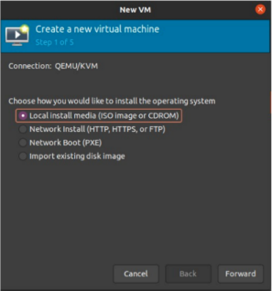

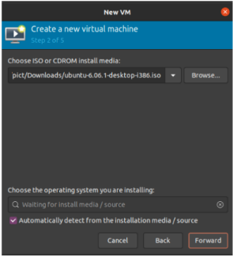

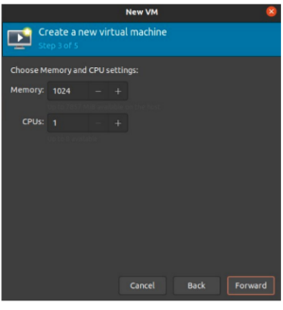

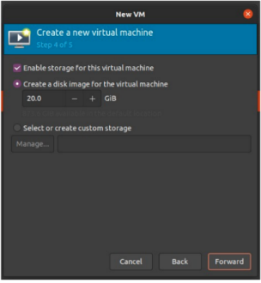

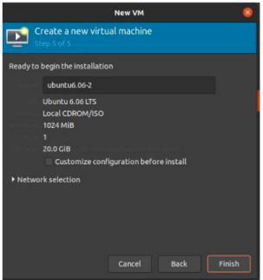

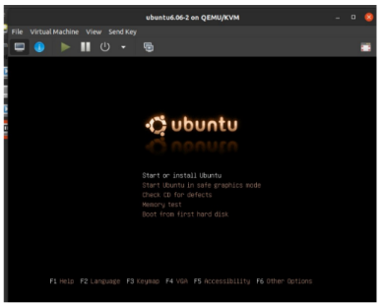

**pict@pict-OptiPlex-9020:~$ virsh list --all Id Name State**

**-------------------------------**

**1 vm1 paused**

**2 fossapup paused**

**5 ubuntu6.06-2 paused**

**- ubuntu6.06 shut off**